**Chalood Nimsamer (1929 - present)**

Since beginning his career in the 1950s, Chalood Nimsamer became one of the most influential Thai contemporary artists. Recognized as a Thai national artist in 1998, Chalood is also a distinguished senior professor who helped develop Thai traditional art in the content of modernism. Most of his work portrays the relationship between Thai local culture and the traditional spirit of Thai people. The variety of his artistic forms: drawing, painting, printmaking, mixed media and installation, represent simplicity and calmness, which the artist claims is the unique character of Eastern culture. His fine delicate drawing lines and gentle colours reflect the love and generosity of rural society. Chalood first gained recognition in the Thai art scene with his early series of tempera paintings, oil paintings, and wood cuts, in which he was inspired by the images of rural women in their daily life. The artist used techniques found in traditional Thai art– organic shapes, vivid colors, and gold leaf– to portray the simple life of Thai people. As a result of these works, including *Thai Farmers* (1955), *Songkran* (1956), Chalood received many awards from the National Art Competition, and eventually gained the title of an artist of distinction (in the field of Painting) in 1959.

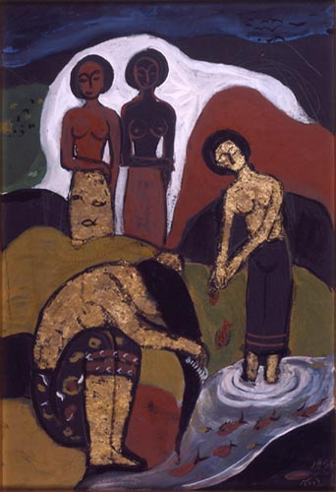

Chalood Nimsamer, *Songkran Festival*, 1956, tempera, 76.5 x 52.5 cm, Collection of Misiem’s Sculpture Garden.

During 1980s and early of 1990s, Chalood created many sculptures installed in public spaces around Bangkok. Most of these sculptures are inspired by Thai culture and Buddhism, for example, the shape of Buddhist pagoda and the shape of “Pod-Duong” or “Bullet Money”, which was of the currency used in the old kingdom of Thailand. In 1982, Chalood introduced the possibility of using local materials to create artworks with his series of performances and installations entitled *Rural Sculpture*.

Chalood Nimsamer was born in 1929 in Thonburi Province, which is today part Bangkok. He is among the first generation of Thai artists who had a chance to study directly under Professor Silpa Bhirasri (Corrado Feloci). Professor Bhirasri later helped the Thai government to establish Silpakorn University, where Chalood became a student and graduated with first class honors, majoring in sculpture. Chalood received a scholarship from the Italian government to study at Accademia di Belle Arti in Rome and another scholarship to study printmaking at Pratt Graphic Center in New York City.

In 1963, Chalood returned to teach at Silpakorn University. His major role of establishing the Department of Printmaking influenced a lot of young Thai artists to create work using this technique, especially in an abstract style. This, along with other factors, led to the successful development of abstract art in Thailand in the 1970s and 1980s. Working as an artist and art professor for more than sixty years, Chalood’s artwork connects two generations of Thai modern and contemporary art, both the early period that was strongly influenced by Western modernism and the later generation of Thai Neo-Traditionalism.

**References and Further Reading:**

Bangkok Art and Cultural Centre. (2012). *Exhibition Catalogue of Chalood’s Mural Painting – Retrospective*. Bangkok: Bangkok Art and Cultural Centre.

Chalood Nimsamer. (2010). *Exhibition Catalogue of Steam of Life : Drawing by Chalood Nimsamer*. Bangkok: Faculty of Painting Sculpture and Graphic Arts, Silpakorn University.

Vichoke Mukdamanee. (2002). *Mix Media and Installation Art in Thailand*. Bangkok: Silpakorn University Art Centre